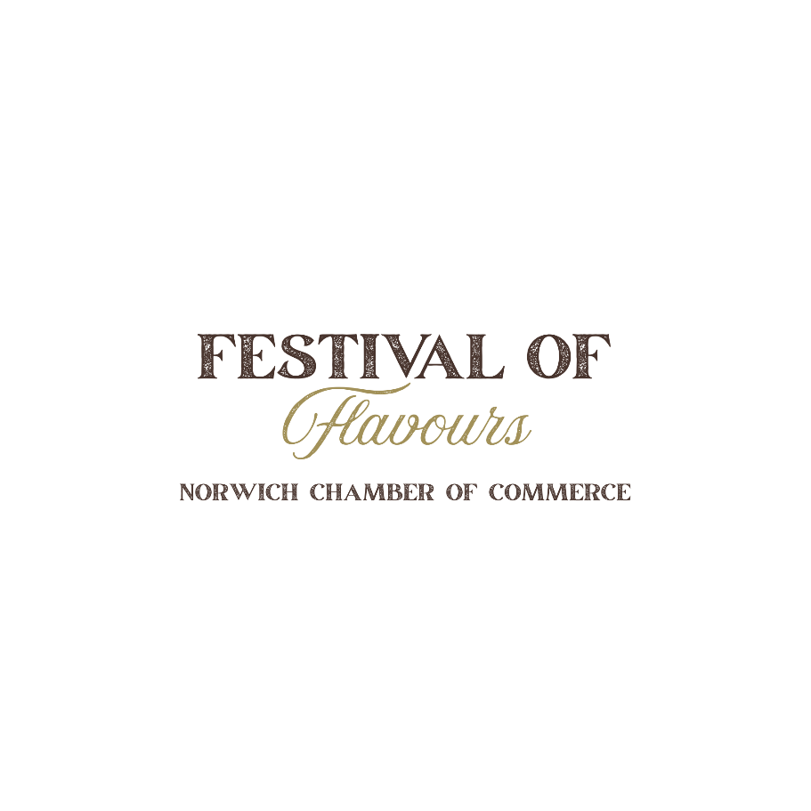

Sponsorship Opportunities
Hosted by the Norwich Chamber of Commerce

Date: Friday, November 6, 2026
Time: 5:00 pm – 10:00 pm
Location: Norwich Community Centre

Support Local. Celebrate Local. Get Noticed.
The Norwich Chamber of Commerce is excited to host the 2026 Festival of Flavours, an evening celebrating the outstanding food, beverage, and culinary businesses throughout our region.
The event brings together local restaurants, caterers, breweries, wineries, distilleries, specialty food producers, and community members for an evening of sampling, networking, and celebration.
We invite local businesses and organizations to become a Festival of Flavours Sponsor and help make this exciting community event possible.
Your sponsorship provides valuable support for the event while giving your business an opportunity to increase its visibility and connect with attendees.
Event Sponsor
$500
Become an Event Sponsor and receive premium recognition throughout the Festival of Flavours.
Event Sponsor benefits include:
- Business logo prominently displayed on event promotional materials
- Recognition as an Event Sponsor on Festival of Flavours signage
- Business logo displayed at the event
- Recognition on Norwich Chamber of Commerce social media channels
- Business name/logo included in event communications, where applicable
- Opportunity to provide promotional materials or business cards for an attendee information area
- Two complimentary event tickets
- Special recognition during the event
Limited Event Sponsor opportunities available.

Table Sponsor
$250
Support the Festival of Flavours while putting your business in front of event attendees throughout the evening.
Table Sponsor benefits include:
- Business logo displayed on a sponsored table at the event
- Recognition as a Table Sponsor on event signage
- Business name/logo included in select event promotional materials
- Recognition on Norwich Chamber of Commerce social media channels
- Opportunity to provide business cards or promotional materials at your sponsored table
- Two complimentary event tickets

Become a Sponsor
We would love to have your business involved in the 2026 Festival of Flavours!
Sponsorship Selection
Business Name: __________________________________________
Contact Name: ___________________________________________
Email: _________________________________________________
Phone: _________________________________________________
Sponsorship Level
Event Sponsor – $500
Table Sponsor – $250
Payment
Payment must be received prior to the event.
Cheques payable to:
Norwich Chamber of Commerce
Mailing Address:
P.O. Box 1028
Norwich, ON N0J 1P0
For sponsorship inquiries or to confirm your sponsorship, please contact the Festival of Flavours Committee.

Festival of Flavours Committee
Norwich Chamber of Commerce
