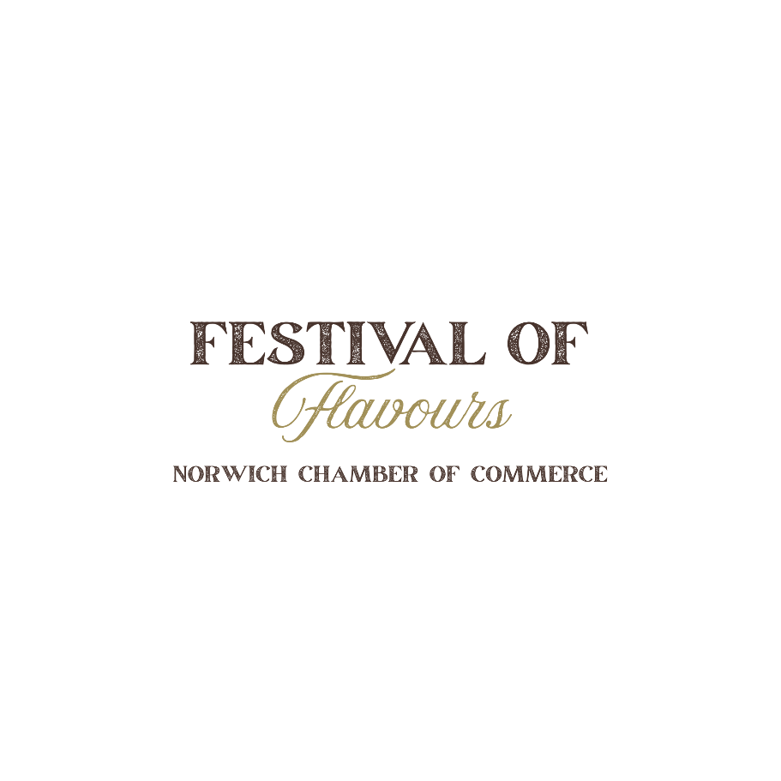

Vendor Information & Application Package
Hosted by the Norwich Chamber of Commerce

You're Invited!
The Norwich Chamber of Commerce is pleased to invite you to participate as a vendor at the 2026 Festival of Flavours.
Date: Friday, November 6, 2026
Time: 5:00 pm – 10:00 pm
Location: Norwich Community Centre

Festival of Flavours celebrates the outstanding food and beverage businesses throughout our region by bringing together local restaurants, caterers, breweries, wineries, distilleries, specialty food producers, and other culinary businesses for an evening of sampling, networking, and community celebration.
This event provides an excellent opportunity to showcase your products, connect with new customers, and promote your business to attendees.
We hope you will join us for another exciting evening of great food, local beverages, and community spirit.
Event Schedule
Vendor Setup:
12:00 pm – 4:30 pm
Public Event Hours:
5:00 p.m. – 10:00 p.m.
Vendor Booth Includes
Each registered vendor will receive:
- One vendor booth
- Two (2) 8-foot tables
- Two Tablecloths
- Access to the kitchen (if required – may need to schedule)
Vendors are responsible for supplying:
- Food or beverage item (let us know your selection to eliminate duplication)
- Serving utensils
- Serving dishes
- Display materials
- Extension cords (if required)
Please note: Electrical access is limited. Vendors are encouraged to use alternative methods of keeping food warm whenever possible.
Vendor Categories
Food Vendors
Restaurants, caterers, bakeries, specialty food producers, food trucks, and other food-related businesses are encouraged to apply.
Beverage Vendors
Breweries, wineries, cideries, distilleries, and beverage producers are welcome to participate.
Sampling & Coupon Program
Guests will purchase digital coupons upon entry and redeem them at vendor booths for food or beverage samples. We are planning on using a digital system that will help vendors keep track of sales, payments, and customer orders in one easy-to-use system.
- 1 Coupon
- 3 Coupons (maximum)
(Final coupon value will be communicated prior to the event.)
At the conclusion of the event:
- Vendors will total all redeemed coupons.
- Festival staff will verify the totals.
- Payment will be issued based on the number of verified coupons collected.

Vendor Fees
Vendor Type | Fee
Norwich Chamber Member | $100
Non-Member | $125
Payment must be received prior to the event.
Cheques should be made payable to:
Norwich Chamber of Commerce
Mailing Address:
P.O. Box 1028
Norwich, ON N0J1P0
Interested in becoming a Chamber member? We'd be happy to provide membership information.
Public Health Requirements
All food vendors must complete the Southwestern Public Health Special Event Vendor Notification Form no later than three (3) weeks before the event.
Notification Form:
https://app.swpublichealth.ca/Forms/SpecialEventVendorNotificationForm
All vendors must comply with all applicable Health Unit, Municipal, AGCO/LCBO, Fire Code, and Provincial regulations.
Vendor Selection
Please note:
- Vendor acceptance is not based on a first-come, first-served basis.
- The Festival Committee will curate the event to provide a balanced variety of food and beverage offerings.

Vendor Application
Please complete the information below.
Contact Information
Business Name:
Contact Name:
Email Address:
Phone Number:
Mailing Address:
Website:
Facebook:
Instagram:

Product/Service: Summary of Offerings:

Type of Vendor
☐ Food Vendor
☐ Beverage Vendor

Utility Requirements
Do you require electricity?
☐ Yes
☐ No
Do you require water access?
☐ Yes
☐ No

Event Activities
Will you be conducting a raffle or prize draw?
☐ Yes
☐ No
If yes, please provide details:

Are you a member of the Norwich Chamber of Commerce?
☐ Yes
☐ No

Vendor Acknowledgements
Please initial or check each item below.
☐ I understand that all food vendors must obtain any required Health Unit approvals.
☐ I understand that my booth must remain open during all public event hours (5:00 p.m.–10:00 p.m.).
☐ I understand that setup must be completed by 3:00 p.m. and teardown may begin only after the event closes.
☐ I understand that vendor acceptance is subject to Festival Committee approval.
☐ I understand that payment for redeemed coupons will be issued following verification by the Festival Committee.

Terms & Conditions
By signing below, I acknowledge that I have read and agree to abide by all Festival of Flavours rules, policies, and regulations.
I agree to comply with all applicable requirements of the Norwich Chamber of Commerce, Southwestern Public Health, AGCO/LCBO, municipal bylaws, fire regulations, and any other governing authorities.
I further agree to indemnify and hold harmless the Norwich Chamber of Commerce, its directors, officers, volunteers, employees, and agents from and against any claims, damages, losses, costs, or liabilities arising from my participation in the Festival of Flavours.

Vendor Agreement
Business Name:

Authorized Representative:

Signature:

Date:

If you have any questions, please contact the Festival of Flavours Committee.
We look forward to welcoming you to the 2026 Festival of Flavours!
Festival of Flavours Committee
Norwich Chamber of Commerce
